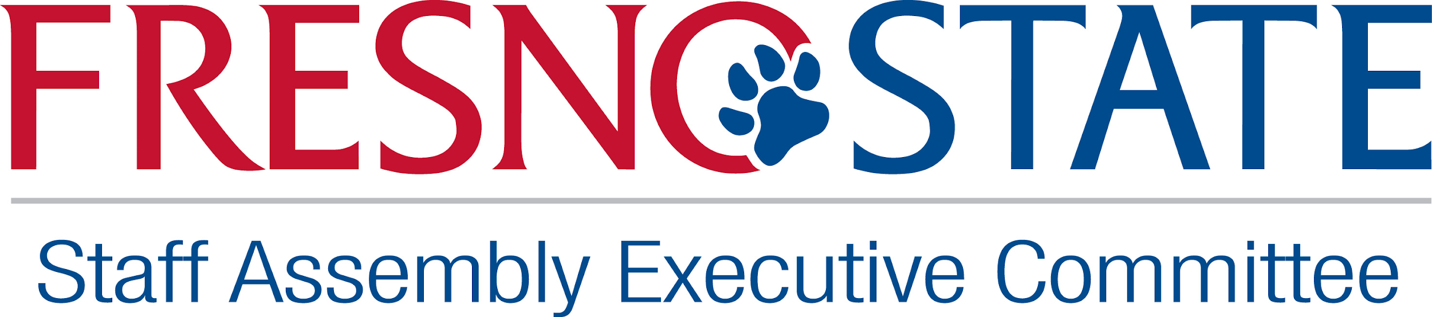

September Monthly Meeting

MINUTESAug 30, 2023

**12-12:30 pm Volunteers and New potential members**

**8.30.23**

Member attendance

**Present: Chris, Patricia, Veronica, Claudia, Belinda, Dolores**

**Absent: Gina, Audrey, Mackenzie, Rose**

Welcome - Belinda Munoz

Discussed utilizing more of Robert’s Rules in our meetings moving forward and the importance of attendance of these meetings as we will be discussing important items that need to be voted on. If any member needs a formal letter please let Belinda know.

Member attendance

**Present: Chris, Patricia, Veronica, Claudia, Belinda, Dolores**

**Absent: Gina, Audrey, Mackenzie, Rose**

**New Business**

* Executive Team Meetings recap, discussing utilizing the recommendations for our group, one of them being using Robert’s Rules in our meeting and trying to organize how we decide/gather our information.
* Weekly meeting for executive team
* Update on volunteers and new potential members, Chair Belinda announced/introduced new members and volunteers. Vice Chair Chris Cruz mentioned that volunteers do not receive all the same information and reminded the group to add these volunteers to help assist in getting them important information.
  + Dolores Ramirez - became a member
  + [Sabrina Fierros](mailto:sfierros@mail.fresnostate.edu)- volunteer
  + Allison Way - volunteer
  + Rose Rosales - became a member
  + Amelia Henkel - volunteer
  + [Yosagandhi Tarvin](mailto:josietarvin@mail.fresnostate.edu)- volunteer
* Update on SAEC meeting with HR
  + Investigation was made into our committee, and one of the findings is that our committee was not following our bylaws properly. Chair Belinda met with the HR manager and discussed the concerns, findings and recommendations for our committee. Chair acknowledged that our committee needed to do better at following our structure. The committee had been working on a better structure and updating the Bylaws and will continue to move forward in making improvements and taking the recommendations from the investigation. One of the recommendations is that exec members of the committee take leadership training. As of now, the investigation has been completed and our committee may move forward with no further action. There will be a request made to close the investigation, once Chair Belinda receives confirmation she let the team know. The Exec team will discuss all members receiving leadership training. This will be tabled for the next meeting.
* Feedback on the mission, vision, bylaws etc
  + Chair Belinda has sent out a spreadsheet for members to vote on our updated mission statement, vision and bylaws that were discussed during the SAEC retreat. There was not much of a response from an email sent earlier, so Chair Belinda created an excel spreadsheet to break the information into easier ways to understand and vote on. Members were asked to participate and vote on by Friday September 29th. These are important to our mission and moving forward as to what our committee needs to do or should do. This will be our guide to check that we are accomplishing the goals in any event that we do in our committee. Member Dolores asked for clarification of the updates of our mission, goals, core values. Was it due to investigation? Or something normally done. Chair Belinda discussed that this was part of the rebranding that SAEC is creating currently and so these mission statements and goals are meant to structure out what the committee will be doing moving forward. Chair Belinda will be working with any available members to solidify these and present for a vote to approve with members next week.

**Patricia!!**

**I have a few notes in todays calendaered note section (FYI) im going to run to another meeting… Is this being recorded? I LOVE YOU THank you! Youre welcome! I do not think it is being recorded so I will add as much as I can**

**Old Business**

* Fall events
  + budget meeting recap: There were about 146 attended online and 26 in person. One of the main topics discussed was the hires before 2014 retirement and those after and the cost associated with that for the campus. The budget went over the increase of costs in living and trying to adjust that in their budget. Most of the questions were answered. Questions were sent over to Debbie Astone and her team, still waiting on a response. Our committee members Audrey Munoz and Vice Chair Chris Cruz are currently working on getting the budget powerpoint on the SAEC website.
  + Red Friday update- Member Veronica Reyes gave an update, Janelle sent a flier, she is checking in catering for the event, confirmation has been sent for use of the RSU Peters Event Plaza. Link to volunteer to host a Red Friday may no longer be in use. Our committee will check and work on adjusting that. For now, the committee will reach out to Departments that usually host Red Fridays in November and December. Notice of our first Red Friday in October has been sent to campus news.
  + Homecoming events
  + Winter Celebration -Veronica showed her plans for the “save the date” flier, members took a vote on which one to use. She will work on that asap. Vice Chair Chris went over the progress from his subcommittee meeting held on Monday 9/25/23. Currently deciding which verbiage to use on the holiday invite; “Holiday Party vs Winter Celebration”. Member Audrey Munoz will be sending the “Save the Date” fliers to cabinet members Admins.

Vice Chair Chris Cruz motioned to adjourn, Paricia Benavides second

Meeting adjourned at 12:38pm

TABLE:

* Update on subcommittees
  + Strategic Planning Group
  + Equity, Inclusion, compensation
  + Recruiting
* Create events leads and members